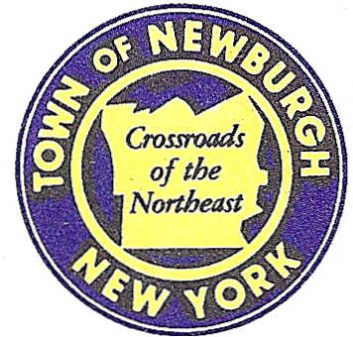

TOWN OF NEWBURGH
_______Crossroads of the Northeast __________________________
OLD TOWN HALL
308 GARDNERTOWN ROAD NEWBURGH, NEW YORK 12550

PLANNING BOARD
JOHN P. EWASUTYN, CHAIRMAN
TELEPHONE 845-564-7804
FAX 845-564-7802
E-MAIL: planningboard@townofnewburgh.org

PLANNING BOARD AGENDA

May 21st, 2020

MEETING CANCELLED

