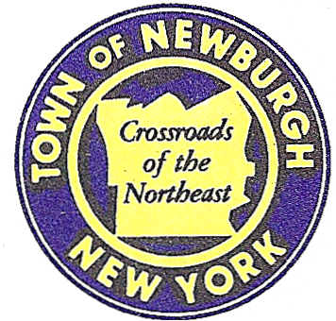

TOWN OF NEWBURGH
_______Crossroads of the Northeast __________________________
OLD TOWN HALL
308 GARDNERTOWN ROAD NEWBURGH, NEW YORK 12550

PLANNING BOARD
JOHN P. EWASUTYN, CHAIRMAN
TELEPHONE 845-564-7804
FAX 845-564-7802
E-MAIL: planningboard@townofnewburgh.org

PLANNING BOARD AGENDA

October 18th, 2018

MEETING CANCELLED

* Next scheduled meeting is to be held on Thursday, November 1st, 2018.

