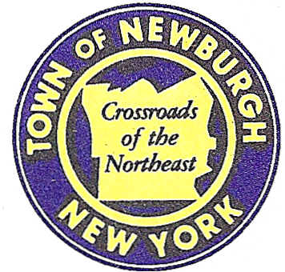

TOWN OF NEWBURGH
_______Crossroads of the Northeast __________________________
OLD TOWN HALL
308 GARDNERTOWN ROAD NEWBURGH, NEW YORK 12550

PLANNING BOARD
JOHN P. EWASUTYN, CHAIRMAN
TELEPHONE 845-564-7804
FAX 845-564-7802
E-MAIL: planningboard@townofnewburgh.org

PLANNING BOARD AGENDA

DECEMBER 3rd, 2015

*PLEASE NOTE: The Planning Board Meeting will start at 7:00 P.M. and all Applicants/Representatives
are to be present at that time. The Meeting will be held in the Meeting Room of Town Hall,
located at 1496 Route 300, Newburgh NY.*

- CVS Pharmacy/Store (2015-23) SITE PLAN
Corel Place (Route 52)
Section 60, Block 3, Lot 5.2
Zone: B
Rep: Cuddy & Feder LLP
300 Westage Business Center, Suite 380
Fishkill, NY 12524
2. Dunkin Donuts (2014-02) SITE PLAN/ ARB
301 NYS Route 32
Section 14, Block. 1, Lot 43
Zone: IB
Rep: Larry Marshall, P.E.
Mercurio Norton Tarolli & Marshall
45 Main Street
Pine Bush, NY 12566

- Westport Management (2015-12)
- 4 LOT SUBDIVISION
Gardnertown Road
Section 47, Block 1, Lot 70
Zone: R-1
Rep: Mercurio-Norton-Tarolli-Marshall
45 Main Street
Pine Bush, NY 12566

4. Vilardi Two-Family (2015-32) INITIAL APPEARANCE
2103 Route 300 SITE PLAN
Section 3-Block 1- Lot 82
Zone: AR
Rep: Maser Consulting, P.C.
555 Hudson Valley Avenue, Suite 101
Newburgh, NY 12550

PLANNING BOARD BUSINESS
WORK SESSION

December 3rd, 2015
5:30 P.M.

Discussion:

1. Healey Kia (2015-25) CONDITIONAL FINAL APPROVAL

2. Long View Farms-Summer Kim (2006-39) extension 4 December 2015 to 4 June 2016

